### Using Bluetooth APP

**iOS system:**

1. Open the APP store

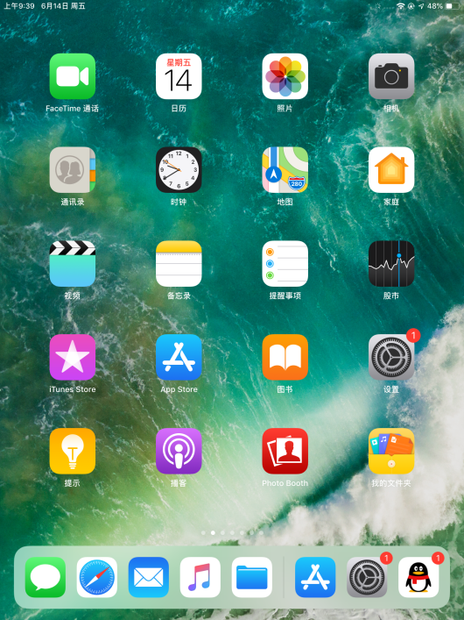

1. Click to search keyestudio, and you will see the keyes BT car.

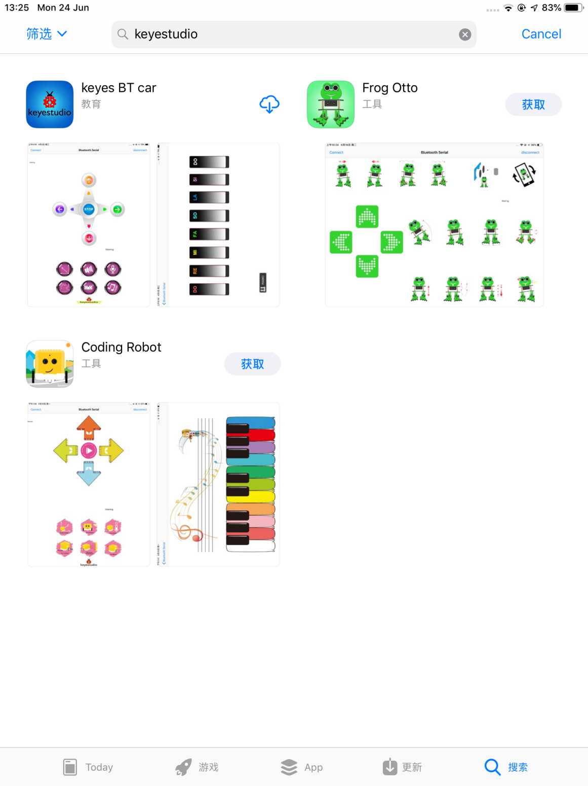

1. Tap to open the keyes BT car
2. To open Bluetooth, click the “Connect” on the upper left corner, searching and connecting Bluetooth.

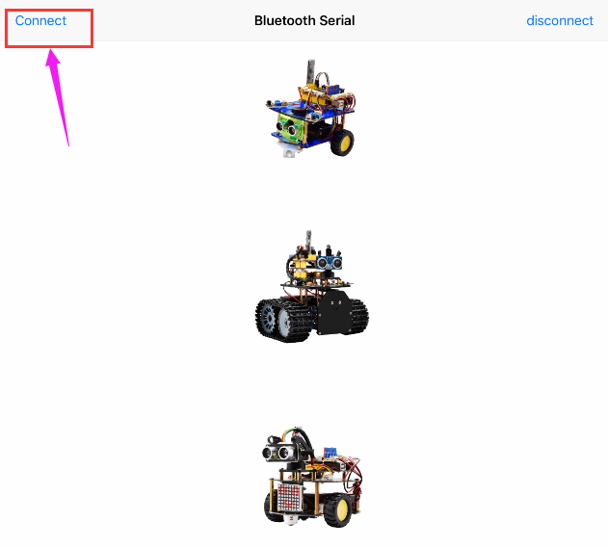

1. Tap the Tank_Car icon to enter the control interface.

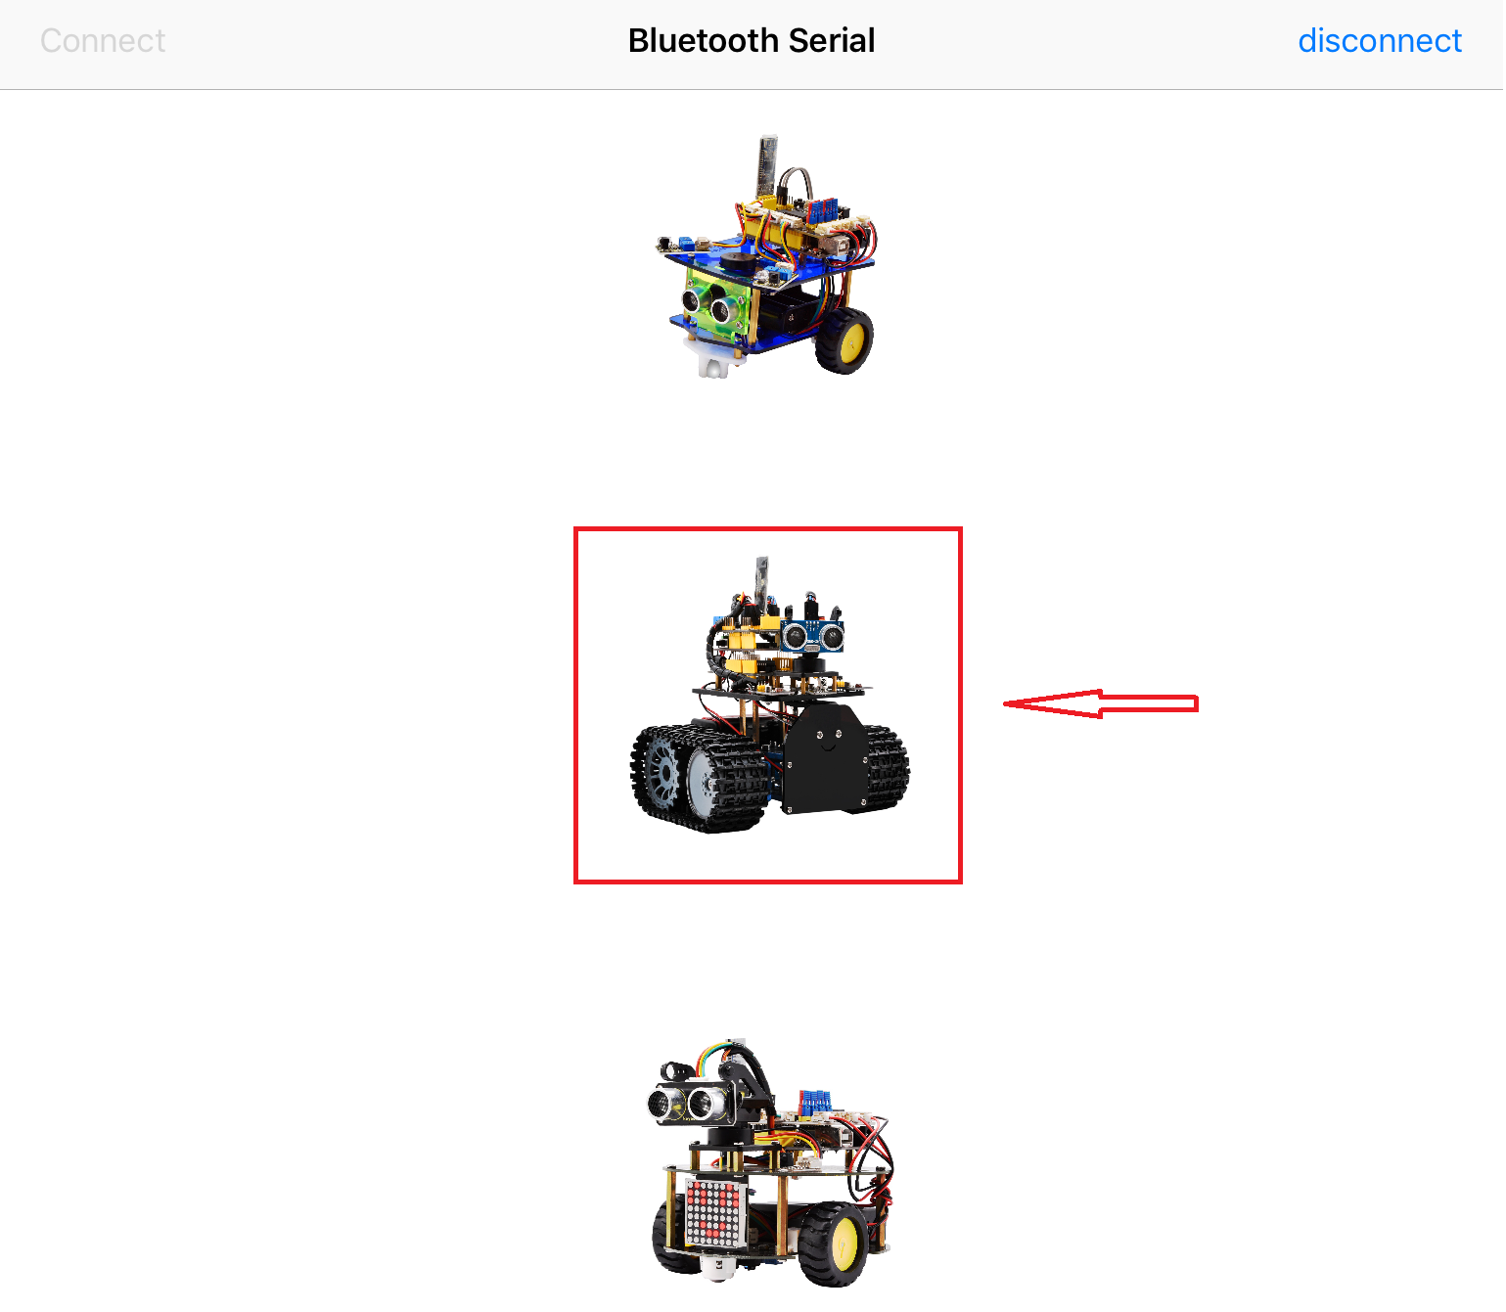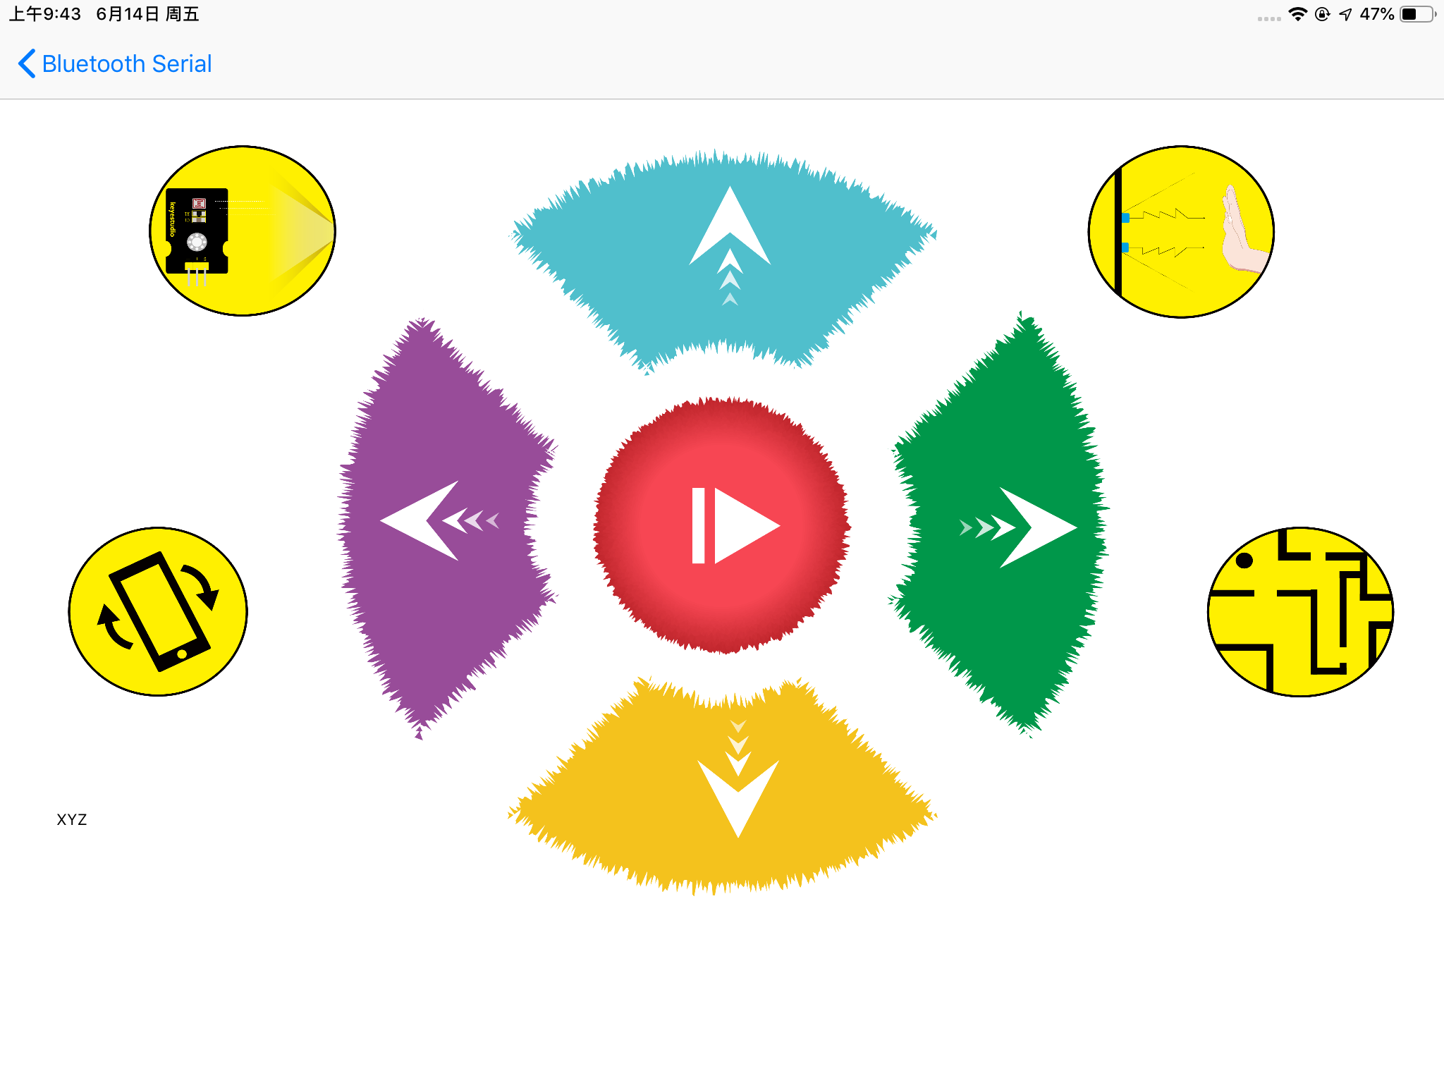

**Below is Tank Robot Bluetooth APP interface and we have listed out what function of each key does:**

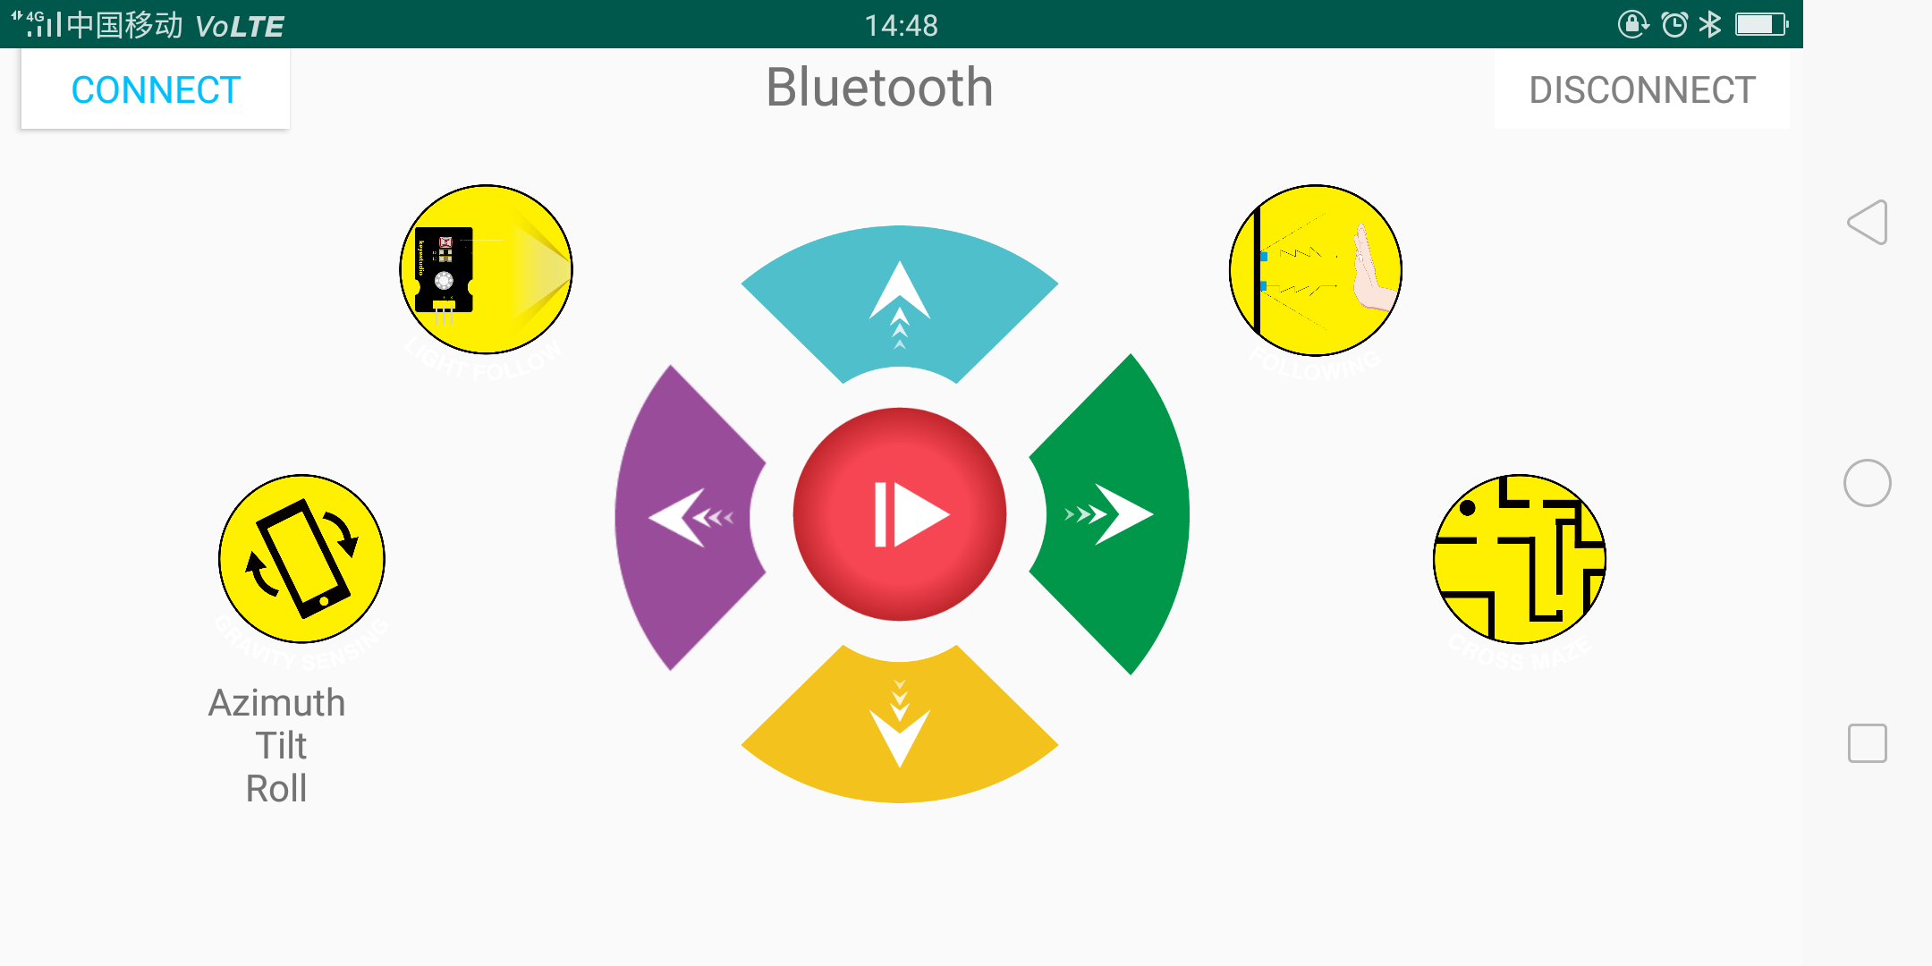

|  |  |  |
| --- | --- | --- |
| **Button** | **Function** | |
|  | pair and connect HM-10 Bluetooth module | |
|  | enter Bluetooth control interface | |
|  | disconnect the Bluetooth | |
|  | **Control character** | **Function** |
| Press: F  Release: S | Press the button, robot goes front; release to stop |
|  | Press: B  Release: S | Press the button, robot goes back; release to stop |
|  | Press: L  Release: S | Press the button, robot rotates to left; release to stop |
|  | Press: R  Release: S | Press the button, robot rotates to right; release to stop |
|  | Click to send：S | Stop |
|  | Click to send “X” | Start light follow function; click Stop to exit |
|  | - | Click to start the mobile posture control; click again to exit |
|  | Click to send “Y” | Start ultrasonic follow function; click Stop to exit |
|  | Click to send “U” | Start ultrasonic avoiding function; click Stop to exit |